**KEY ABSTRACTIONS**

Customer

Account

AccountType

**USE CASES**

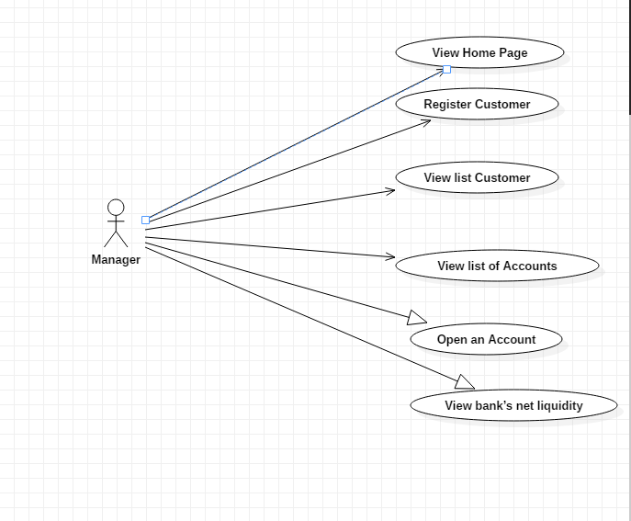

Class Diagram

